MECAA/MEAMA
Middle-East Academy for Medicine of Ageing

Application form

REGISTRATION FORM
Print your name exactly as you want it to appear in your Certificate of Attendance
First Name: Middle Name Last Name

CLINICAL FIELD:
Ο health care Ο education Ο management Ο Allied health
Ο physician Ο nurse Ο administrator Ο Others

Title : Prof. Dr. Mr. Ms.

Position :____________________________________________________________

Department :____________________________________________________________

Email :_____________________________ Mobile:_____________________

Hospital :________________________________Fax:_______________________

Country : ___________________________Tel. No. (Home)________________

Curriculum vitae : as enclosure
Reason of application : ………………………………………………………………….

applying to Ο MEAMA Session
Ο MECAAA Conference

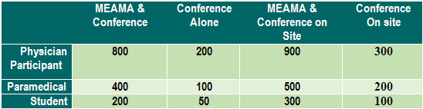

Registration forms should be e-mailed to MEAMA Secretariat, Mrs Hiba Shaarani
Abyad Medical Center. Tel & Fax: 961 6 443 684/5/6 E-mail: aabyad@cyberia.net.lb

